**Visualization Application**

Shin Gao (tg2618)

**Name: “Find your ideal city”**

**Data Source:**

Data source: <https://data.world/shinnknight/software-engineer-career-condition/workspace/file?filename=citi.xlsx>

**Analytical Tool:**

R-Shiny, Tableau, Excel, data.world.com

**Description:** An interactive informational platform enabling users to make a better recommendation.

This is an interactive platform to help the junior professionals better understand the work and life environment in different cities in America.

In our Alpha version, the service is only for the talents hunting jobs in software engineer, since it’s the one of the most popular positions right now.

**Goals:**

1. Identify specific user needs (i.e. education) based on findings from user search activities.
2. For Investment & Future Planning (locations & industries & government)

**Analytical Roadmap:**

1. Identified essential variables (12 variables):

STATE, City, Total Employment, Jobs density (per 1000), Hourly salary, Annual salary, Rental, living rage, education, criminal rate, tax rate, entertainment

1. Recommendation System

* Common size Analysis
* Ranking system:

1. Preference Analysis

* Young professionals:  Offers suggestions about expectancy
* Companies: Provides favored offering (e.g. housing, education, entertainment)
* Local governments: Place budget in perspective - Allocate resources based on professionals’ talent

**Function framework:**

1. After log into the platform, you can see the interface as below.

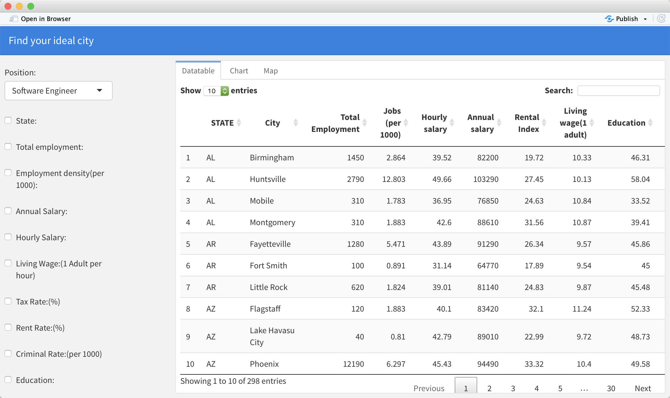

Data table

Left Sidebar

Switch tab

It is the main page, and on the left sidebar, the users are allowed to customize their personal criterion to filter the cities. While on the right side is a dataset table, which shows the features of the most popular cities.

1. Switch the tab bar on the top of the table, we go to the “Chart Page”

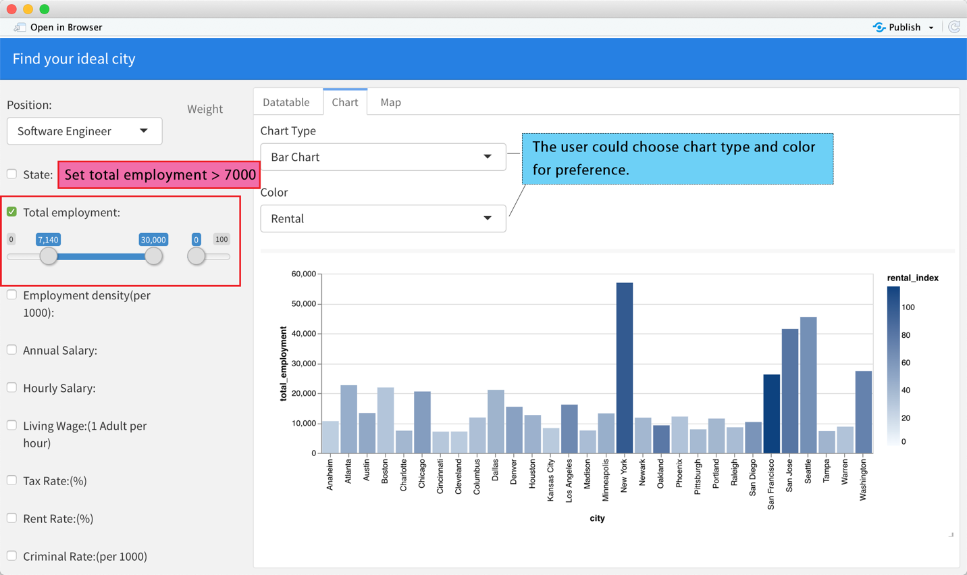

Still, on the left sidebar, we could set conditions to filter the data, here, we set “total employment > 7140”, then the data on the right will change automatically. And on the right, it’s the chart page, we could set “Chart Type” and “Color”, the chart will display on the right bottom.

It’s very easily to change the chart type to Area Chart, for example.

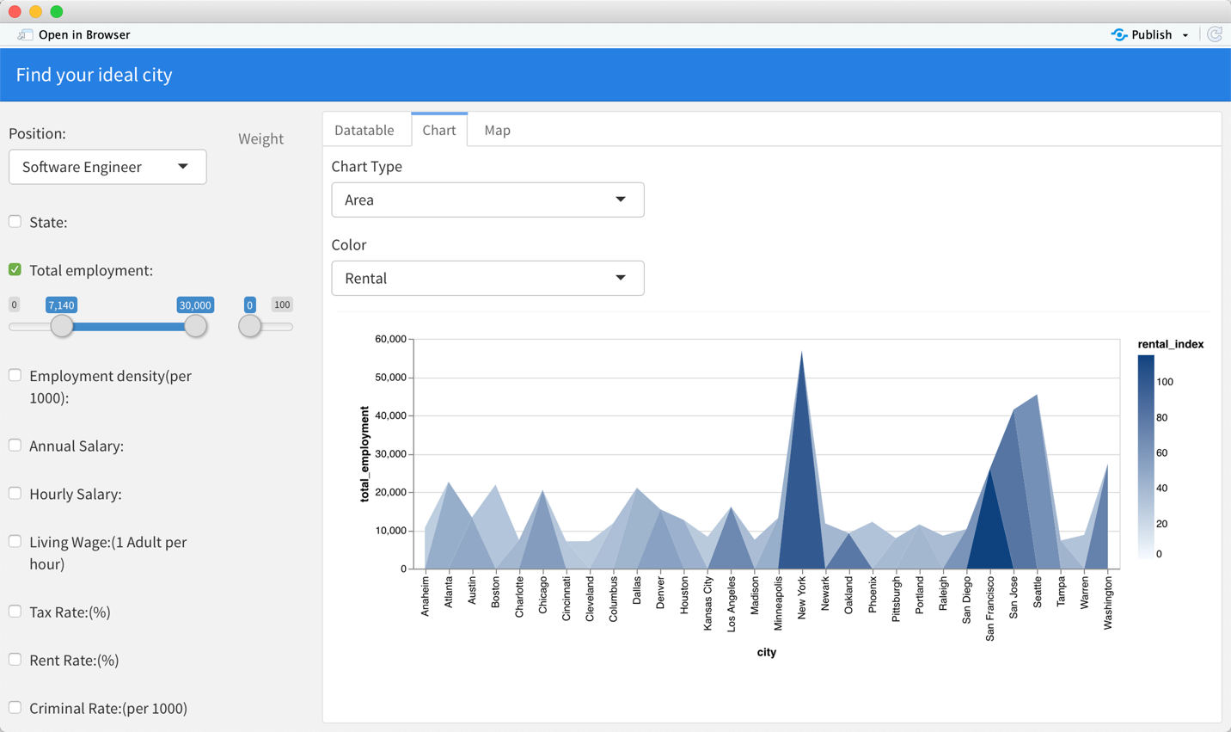

1. Next, the “Map” tab tag will lead the user to the “Map Page”

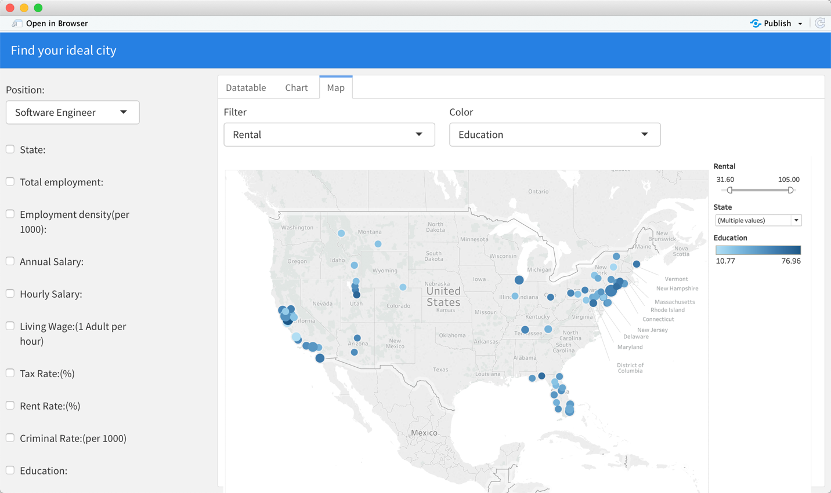

Set filter and

color parameter

Map plot area

Data filter sidebar

On this page, the user can easily plot the city points on the map, which enables them to get the location of each city straightforward.

They can also use ‘Filter’ and ‘Color’ boxes to format the map, visualize the map in their preferred way.

**Functions:**

The app is supposed to act as an information search engine to serve junior professionals to look for the best city to live. And the ultimate goal is to give the user recommendations according to their preference.

Basically, the analytical functions can be separated into 2 part.

**Part 1. We want to give the user a ranked list of cities, indicating which cities are the fittest ones for them.**

On the left sidebar, the user could choose the job positions and choose the conditions they care about. For example, if you want to limit the annual salary to filter the output. Just tick the “Annual Salary” box, and set the range, also you could set the weight on that feature. Then based on the features and weight, the backend will give a ranked city lists for the user.

There is an underlying algorithm here, after the user sets conditions, the backend not only filter out the cities qualified for the standard, but also score them according to the weights.

For example, if we set “Annual Salary” is between “65,000 to 145,000” and give weight to 29/100, the table listed on the right is the ranked table after calculation.

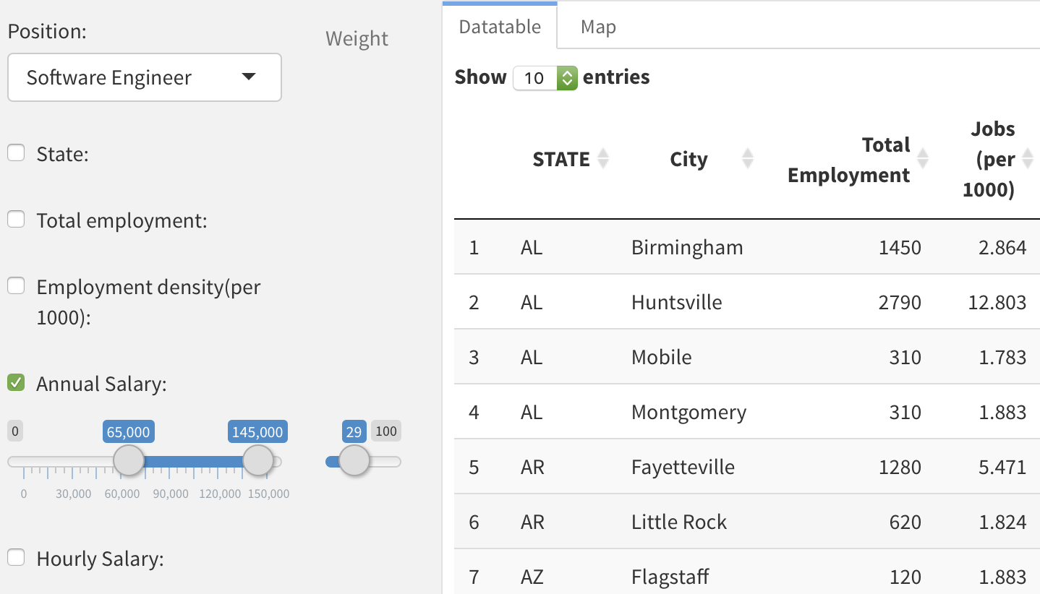

**Part 2. We give recommendations based on general search.**

After the platform runs for a long period, we could do statistics about which features are most often used by users. And how much they care about the feature (the weight), and what are the cities are most popular for a particular position.

For example, we found that people who look for software engineering positions are more likely to set the annual salary between $80,000 to $120,000. Then we can give recommendation that the expectation annual salary is about $100,000 for those new users who are seeking “Software Engineer” opportunities.

Also, the user (including enterprises, HRs) could use the platform to get more deep information.

For example, the user could plot out the distribution of hourly salary. So, he or she could have a rational hourly salary range for the job.

The user can also show the data on the map, for example, they can see how rental fee is like in different state.

**Storyboard:**

Layout:

